**Salesforce Developer Coding Challenge – Burnt Wood**

Task – 1 (field based)

Customer classification – Formulae field to populate Classification values like ‘Gold, Silver, and Bronze’ based on the value in Total Customer Spend field.

Total Customer Spend – Roll up summary field to calculate the cumulative Amount of opportunities related to that Account with filter applied based on current stage of related opportunities.

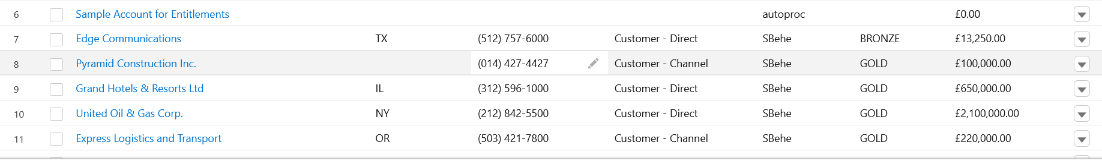

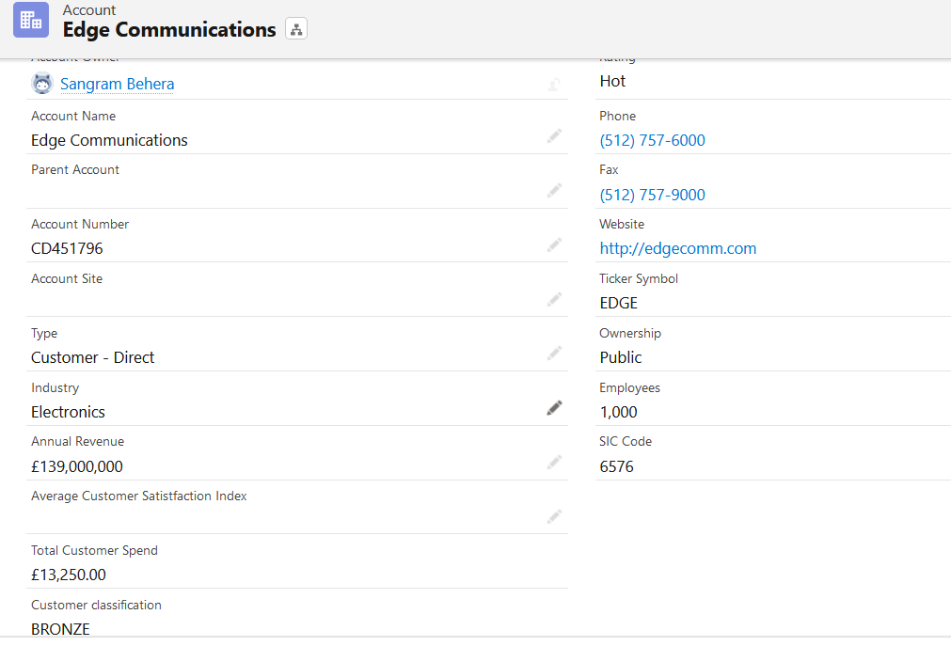

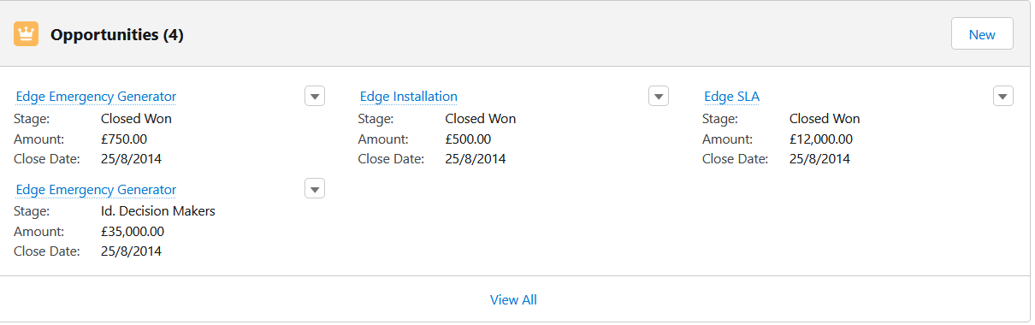­­

Task-2

Initiate SMS

*Apex trigger based on Classification field and new filed to identify first time gold user.  
*A callout to trigger SMS with Twillo endpoint and Access token is written in Future method for Async callouts.  
*Twillo URL is added to Remote site settings for allowing the external connectivity.  
  
Task -3  
Created a LWC with rich-text input and button – have added the LWC in App builder page with condition based on Account Classification field.  
On click of send button, Account name,Mobile number and text in input will be sent to apex to trigger callout created in task-2.

